# RAJALAKSHMI ENGINEERING COLLEGE

Department of Electronics and Communication Engineering IOT ASSIGNMENT

Topic: Assignment on home automation using Arduino Name: BALASUBRAMANIAM CS

1.WriteCodeandconnect onsinwokwiforu trasonicsensor.whatever d stanceisless than100cms send“Alert”toibmcloudaand

d splayindevicerecentevents.

Solut on:

//Pins

const int TRIG_PIN = 7

;constintECHO_PIN= 8;

//Anythingover400cm(23200us pulse)is"outofrange"constunsignedintMAX_DIST=2320 0;

voidsetup(){

//TheTriggerpinwilltellthesensortorangefindPin Mode(TRIG_PIN, OUTPUT);

digitalWrite(TRIG_PIN,LOW);

//SetEchopinasinputtomeasure the duration of

//pulsescomingbackfromthedistancesensorpinMode(E CHO_PIN,INPUT);

//We'llusetheserialmonitortoviewthesensoroutputSerial. begin(9600);

}

voidloop(){unsi gnedlongt1; unsignedlongt2; unsignedlongpulse_widt h;floatcm;

floatinches;

//Holdthetrigger pinhighforatleast10usdigitalWrite(TRIG_PI N,

HIGH);delayMicroseconds(10);digitalWrite (TRIG_PIN, LOW);

//Waitforpulseonechopin while(digitalRead( ECHO_PIN)==0);

//Measure howlongtheechopinwas held high(pulsewidth)

// Note: the micros() counter will overflow after-70 mint1=micros ();

while (digitalRead(ECHO_PIN) == 1);t2=micros ();

pulse_width= t2-t1;

//Calculate distanceincentimetersandinches.Theconstants

//arefoundinthedatasheet,andcalculatedfromtheassumedspeed

// of sound in air at sea level (-

340m/s)cm=pulse_Width /58;

inches=pulse_width/148.0;

//Printout results

if (pulse_width >MAX _ DIST

){Serial.println("Outofrange ");

} else

{Serial.println("*******************************”);Serial.pri nt("The Measured Distance in cm: ");Serial.println(cm);

if( cm<100){

//while(true){ Serial.println(“Alert!!”);

//}

}

Serial.print(“***********************************”);

}

//wait at least 1000ms before next measurementDelay(1000);

}

# Output

1. If the distance is less than 100cms,it alerts.

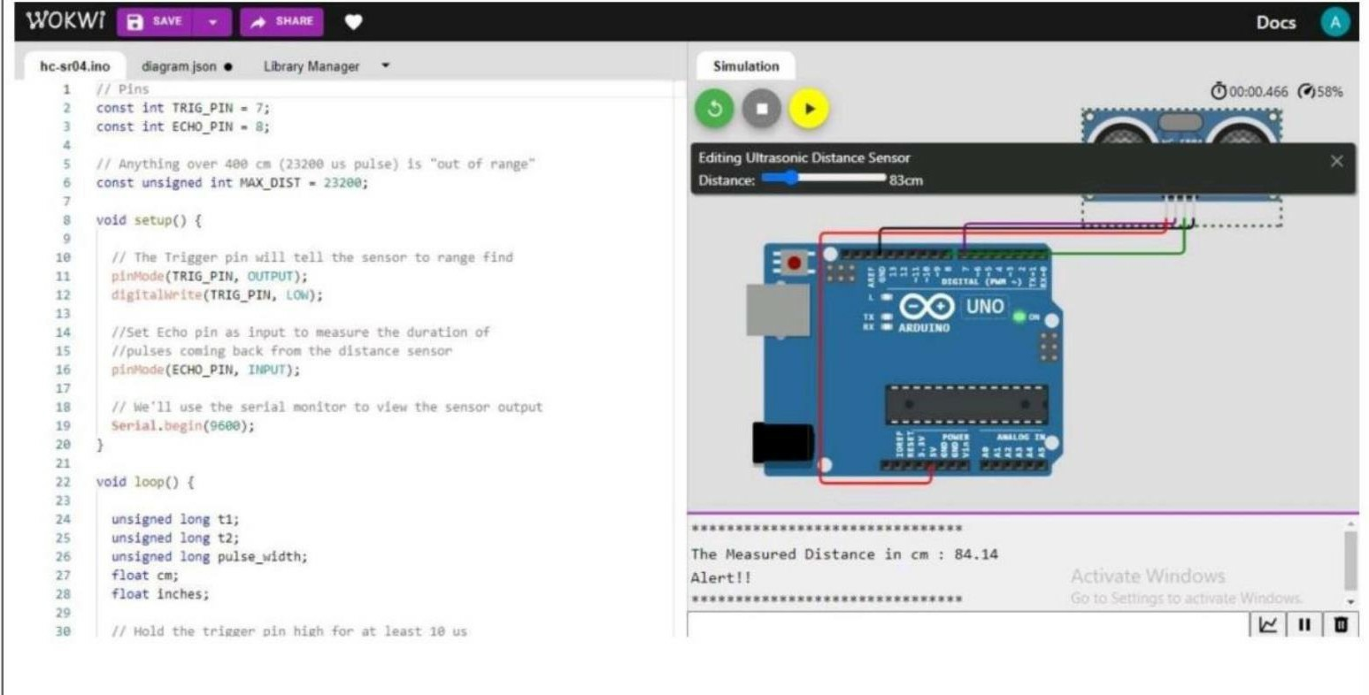

1. If the distance is more than 100 cms, it won’t alert

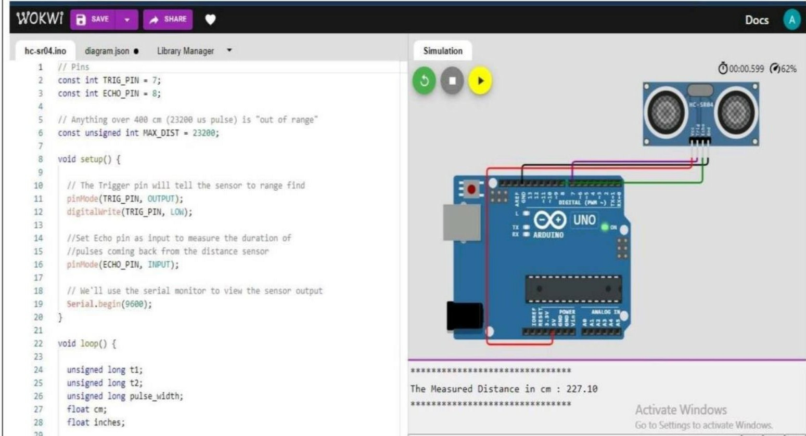

1. S mu at on and code execut on

